Factors Affecting Resistance:
- Nature of the materials (resistivity)
- Cross section of conductor
- E.g.
- Length of conductor
- Shorter (lower Resistance)
- Longer (higher resistance)
- Temperature

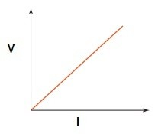
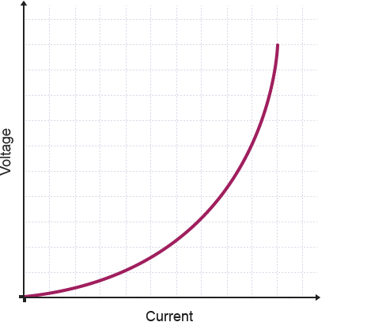
Ohmic
It is linear
Non-Ohmic
It is non-linear

Ohms Law :
V= Potential difference (Volts)
I= Current (amperes)
R= resistance (Ohms)
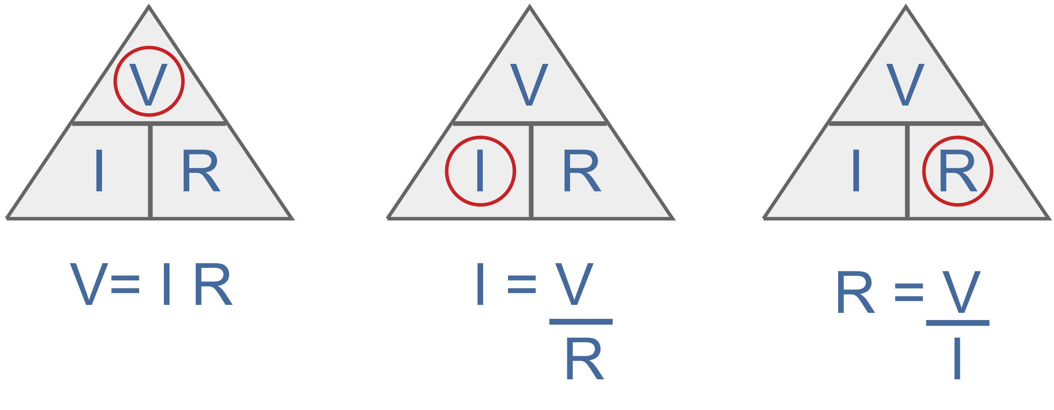
**If non-ohmic we do a specific point in the graph
e.g. A power line has a PD of 250V and a resistance of 1.0Kῼ
PD= 250V R=1000ῼ I=?
V=IR
250=1000xI
I= 250/1000
=0.25 A
Conventional Current:
as moving in the same direction as the positive charge flow. (positive -> negative)
Electron Current:
is what actually happens and electrons flow out of the negative terminal, through the circuit and into the positive terminal of the source. (negative->positive)

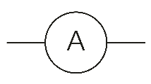
Ammeter:
Use for current
- Place it anywhere in circuit
- Connect in series
- Internal resistance is very small
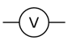
Why its connected in series
Ammeter measures the electrons, therefor they need to go through it
Why does it have a low resistance?
Because you don’t want to block the charge flow
Voltmeter:
Use for potential difference
- Connect in parallel
- Internal resistance is very high
Why are voltmeters connected in parallel across a resistor?
Because we want to know the voltage across a certain element, so either side. Voltage is the electric potential difference between two points of space. There is no point of asking what the voltage through a circuit is
Why do volt meters have a high resistance?
We want to make sure minimal current is going through the Voltmeter. So, by having a high resistance it makes sure the current flows through the resistor.

What is a rheostat and its function?
It is a variable resistor. - you can change the resistance
*Function is to regulate/ identity the current flow, it also ensures the circuit doesn’t blow
Why can a voltmeter and ammeters be connected one way, but it doesn’t matter with resistors?
The meter can only go one way (polar). They both have a – and + positive terminal and the dial can go only one way. For resistors it doesn’t matter due to the current being able to go any direction.

